**Practice Exercise 1 - Lab Report**

Department of Computing, United States International University - Africa

DST4010: Distributed Systems

Prof..Linus Aloo

September 28, 2021

Samroberts B. Wanjala 660106

Ombiro Clifford 660904

Cliff O. Mboha 658785

Ndirangu Cynthia Wangare 658675

Najma Abdi 659808

1. **Phone details**

**Cell Tower 0**

Smartphone 2

UUID: 0001.4279.85DE

Smartphone 3

UUID: 0090.2B8B.C528

**Cell Tower 1**

Smartphone 0

UUID: 0001.425B.BB42

IP Address: 169.254.44.75

Subnet Mask: 255.255.0.0

Link Local Address: FE80::201:97FF:FE08:2C4B

Smartphone 4

UUID: 000B.BE2D.E775

IP Address: 169.254.199.106

Subnet Mask: 255.255.0.0

Link Local Address: FE80::2E0:A3FF:FEA9:C76A

Smartphone 1

UUID: 00E0.F91D.1D60

IP Address: 169.254.203.7

Subnet Mask: 255.255.0.0

Link Local Address: FE80::290:CFF:FED2:CB07

1. Communication between:

Smartphone 0 and smartphone 2, smartphone 1 and smartphone 3

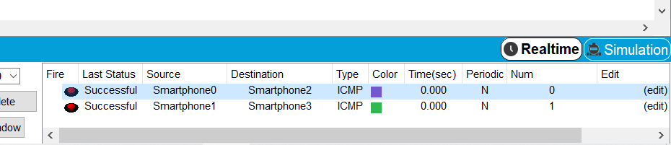

The smartphones communicate using the 3G network and the central office server routes the packets from one cell tower to the other to allow for communication from devices using different cell towers.

1. **Key characteristics**

**GSM**

* Data transfer rates of upto 64kbps
* Usage of digital signals instead of analog signals
* Ability to send and receive SMS and MMS
* Higher quality voice calls
* A bandwidth of 30 to 200kHz

**3G**

* Up to 2Mbps speeds
* Increased data transfer rates and bandwidth
* Large email messages can be sent and received
* It has broadband capabilities and large capacities

**4G**

* Interactive multimedia, audio, and video are all supported.
* High-capacity, high-speed, and low-cost per bit.
* Mobile networks that are both global and scalable
* Multi-hop and ad hoc networks.

**5G**

* bands in the 30 GHz to 300GHz range
* Uses MIMO(Multiple Input Multiple Output) and mmWave.
* 5G has low latency.

1. **Main elements of the network**

**GSM**

GSM is also known as 2G. 2G networks use digital radio frequencies. 2G capabilities were attained by through multiplexing to allow numerous users on a single channel. Cell phones were used for data as well as voice in 2G.

**3G**

It is also known as HSPA+. The main network architecture of the 3G standard is the Universal Mobile Telecommunications System(UMTS). For a much faster data rate, the 3G network combines parts of the the 2G network with new technology and protocols. Through packet switching, 3G has improved rates of up to 14Mbps. It utilized Wide Band Wireless Network to improve clarity. It has a 2100 MHz frequency range and a bandwidth of 15-20MHz. The International Mobile Telecommunications-2000(IMT-2000) were the requirements for the 3G network; the theoretical maximum speed of HSPA+ is 21.6 Mbps.

**4G**

It is also called LTE. The key distinction between 3G and 4G is the data rate. There is also a significant difference between 3G and 4G technology. MIMO(Mulltiple Input Multiple Output) and OFDM(Orthogonal Frequency Division Multiplexing) are two fundamental technologies that have made the 4G network possible. WiMAX and LTE are the two major 4G standards.

**5G**

The 5G range testing in mmWave yielded findings at a distance of about 500 meters from the tower. The implementation of 5G with millimetre wave-based carriers can improve total coverage area by using small cells. Small cells, when used with beamforming, can provide incredibly fast coverage with low latency. The 5G networks is based on scalable Orthogonal Frequency-Division Multiplexing. This favors 5G, which can have latency as low as one millisecond, with realistic estimates ranging from one to ten seconds. The speed of 5G is expected to be 60 to 120 times quicker than 4G.

1. **Simulation screenshot**

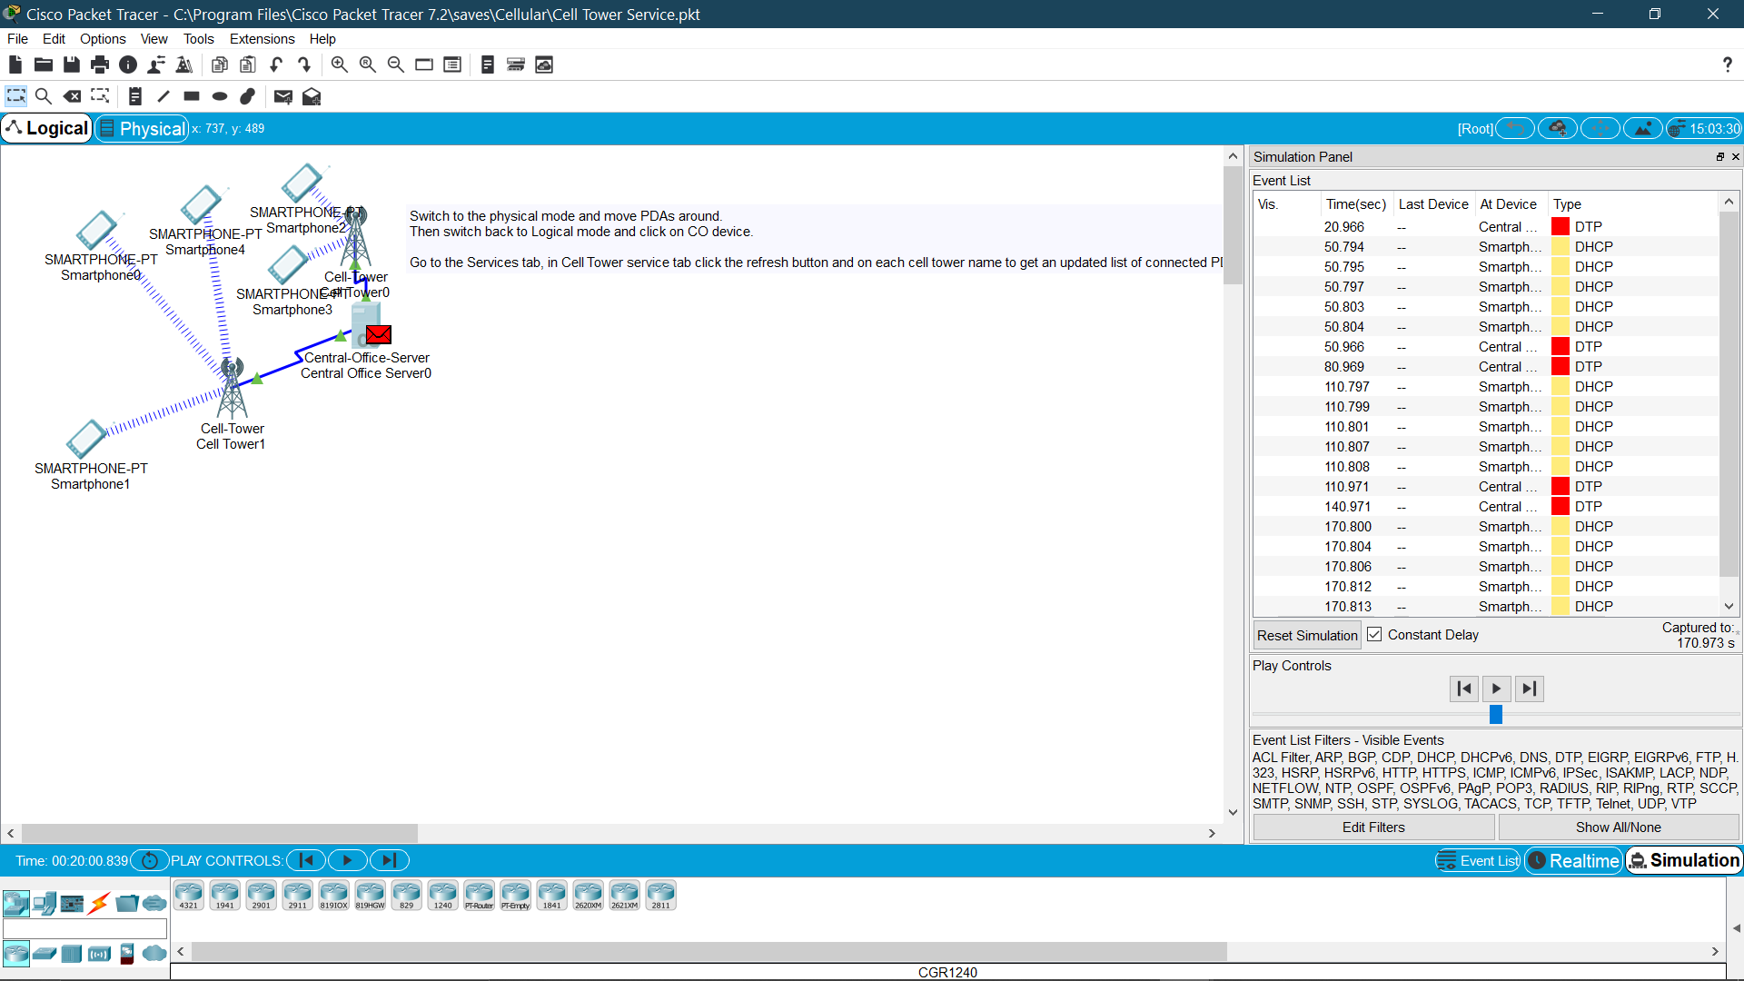

1. **Interpret important details of each device**

**Smartphone 1**

It has 3G/4G capabilities and utilizes an Ipv4 address(169.254.203.7/16).

**Cell tower 1**

This cell tower supports 3G/4G and uses a coaxial connection.

**Cell tower 0**

This cell tower supports 3G/4G and uses a coaxial connection.

**Central Office Server**

It has an IPv4 address of 172.16.1.1 and it is used as the gateway by all the devices.

**Smartphone 0**

It has 3G/4G capabilities and utilizes an Ipv4 address.

**Smartphone 4**

It has 3G/4G capabilities and utilizes an Ipv4 address.

**Smartphone 2**

It has 3G/4G capabilities and utilizes an Ipv4 address.

**Smartphone 3**

It has 3G/4G capabilities and utilizes an Ipv4 address.

**7.**

**Security is a crucial element. Otherwise all the investment involved in creating the network will be threatened**

**Scalability… the network should be able to be downsized to save costs on unused resources or upsized to avoid having to create a whole new network**

**Training in the long run is important in success**

**Conclusion**

Innovation in wireless, network and communication technologies the entire planet will be interconnected with no boundaries. Advance in this technology has allowed for delivery of excellent and unrivaled data capacity, unrestricted call volumes, and huge data transmission. Access to information, engagement, and entertainment is continuing to be universal and unlimited, in turn the world will need to adopt new, better and faster ways of going about their lives.

**REFERENCES**

*Comparison of 2G 3G 4G 5G | 2G vs 3G vs 4G vs 5G | Rantcell*. (n.d.). Retrieved September 27, 2021, from<https://rantcell.com/blog.html>

About » Blog » Key Factors to Consider When Creating an IT Network  
  
Read more at: <https://www.stratospherenetworks.com/blog/4-key-factors-consider-creating-network/>